Technical Specification

WRICEF ID.: | BAPI
Project Name: | Support Project
Client Name: | EVER ENVIRO
WRICEF Description: | BAPI (For invoice deletion)

TECHNICAL SPECIFICATION

Section 1: General Information
Project: | Support Project | Functional Area: | SD
VSD Functional Consultant | Harish Giri and Rohit Mahaveer | VSD Developer | Shivani Jha
Object Name: | BAPI
Object Id
Description | BAPI for Invoice deletion
Development Class |  |  |  | Package
Package | ZSD
File Name & Location in Solution Manager for FSD
File Name & Location in Solution Manager for TSD
Menu Path: (if applicable)
Mode | Foreground Background
Frequency | Monthly Weekly Daily Adhoc Others
Title:
Application Key: | NA
Complexity: | High Medium Low

Table of Contents
1 Scope Summary 5
1.1 Development Objects per System 5
2 Business Details 6
2.1 Summary / Business Background 6
2.2 Assumptions 6
3 Development Scope 7
3.1.1 Detailed Process Description 7
3.1.2 Data Model 7
3.2 Web Service - NA 7
3.2.1 Configuration 7
3.2.2 Development Objects 7
3.2.3 Business Logic 7
3.2.4 Error Handling 7
3.3 Workflow Development - NA 8
3.3.1 Configuration 8
3.3.2 Business Object creation / extension 8
3.3.3 Triggering Mechanism 8
3.3.4 Creation/Change of Workflow 8
3.3.5 Workflow Business Logic 8
3.3.6 Error Handling 8
3.4 Reports 8
3.4.1 Selection Screen 8
3.4.2 Business Logic 8
3.4.3 Output Format 8
3.4.4 Run Mode 8
3.4.5 Error Handling 8
3.5 Forms - NA 9
3.5.1 Layout Details / Sample Formats 9
3.5.2 Business Logic for Data Retrieval 9
3.5.3 Triggering Mechanism 9
3.5.4 Special Considerations 9
3.5.5 Error Handling 9
3.6 Dialog program / Web Developments (PCUI - BSP / WebDynpro) - NA 9
3.6.1 General 9
3.6.2 Screen Sequence 9
3.6.3 Business Logic 9
3.6.4 Bespoke Tables Updated 9
3.6.5 Error Handling 9
3.6.6 Multi-User Access Consideration 9
3.6.7 Branding Requirements 9
3.6.8 Screen layout 9
3.6.9 Field Definition 9
3.6.10 Menu implementation 9
3.6.11 Database update processing 10
3.7 Enhancements - 10
3.7.1 List of Enhancements 10
3.7.2 Business Logic 10
3.8 SAP PI – ABAP Proxy Development - NA 10
3.9 Class / Interface Development - NA 10
3.10 IDOC Development - NA 11
3.10.1 General 11
3.10.2 IDoc Customizing 11
3.10.3 Record Layout 11
3.10.4 Extension 11
3.10.5 IDoc Type 11
3.10.6 Message Type 11
3.10.7 Logical System 12
3.10.8 Process Code 12
3.10.9 Distribution Model 12
3.10.10 Transactional RFC Port 12
3.10.11 File Port 12
3.10.12 XML File port 12
3.10.13 XML HTTP 12
3.10.14 Partner profile 13
3.10.15 Inbound/outbound Parameters 13
3.10.16 Message Control 13
3.10.17 IDoc Processing 13
3.10.18 ABAP Processing 13
3.10.19 Description of Output 13
3.10.20 Programs/function modules for creation of IDOCs 14
3.10.21 Error handling for inbound/outbound (link to any workflow developments) 14
3.10.22 FTP scripting requirements 14
3.11 Function Module / RFC / BAPI - NA 14
3.12 Data Dictionary Objects - NA 16
3.12.1 Bespoke Table 16
3.12.2 Search helps 17
3.12.3 Lock Objects 17
3.13 Actions - NA 17
4 Authorizations 18
5 Message Class and Messages 19
6 Archiving – NA 20
7 Unit Test 21
7.1 Unit Test Specification 21
7.2 Test Data or Sample file 21
8 Version Control 22
9 Glossary - NA 23

Scope Summary

Development Objects per System
S.No | System | Package | Development  Object | Description
 | S4HANA | ZSD | BAPI | BAPI pgm for Invoice deletion

Business Details

Summary / Business Background

Title | Invoice deletion pgm
Description | BAPI pgm for invoice deletion
Business purpose | For delete bulk invoices document using BAPI
Application area | SD
Tcode | ZINV_CANCEL

Function Module BAPI -

Function Module Name | BAPI_BILLINGDOC_CANCEL1
Function Module Text | Cancel Customer Individual Billing Document
Type of Function Module | Remote-Enabled
Function Group | 2032
Business Object | BUS2032

Business Logic | As per the excel sheet data pass data into BAPI parameter and cancel billing document
Error Handling | Before run BAPI, excel sheet validations are there  1.Excel should be .xls or .xlsx formate other wise pgm throw error message.  2. If upload blank excel then pgm throw error.  After run BAPI.  For error handling got return table in BAPI. As per the return table output show result in ALV of BAPI program ZSD_INV_MASS_CANCELTON and tcode is ZINV_CANCEL.

Unit Test

Unit Test Specification
After upload file in BAPI pgm output show in ALV report.

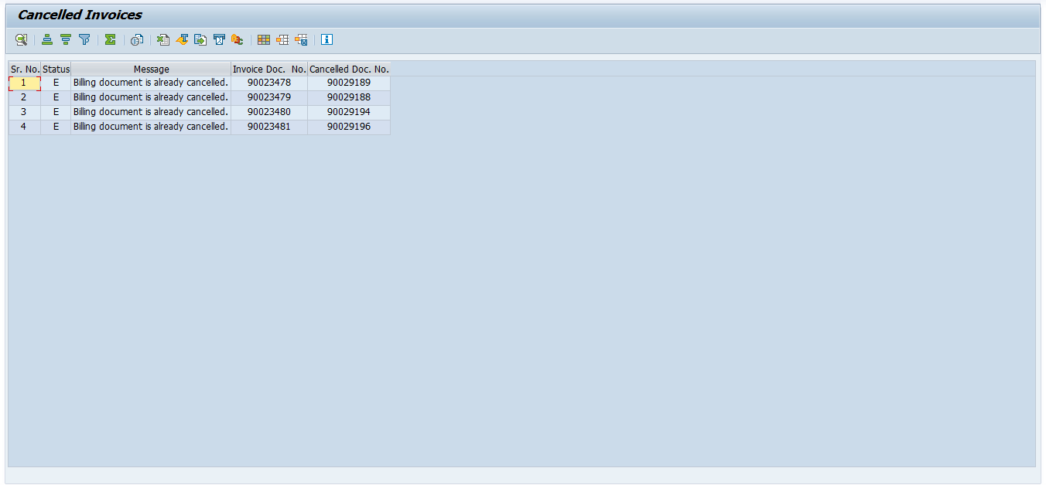

Test Data or Sample file
here is referanceof upload excel sheet.
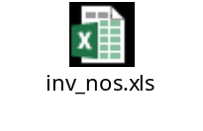

Version Control
Version | Date | Comment/Changes | Completed By | Transport
 | 10.03.2025 | VSD: driver pgm - one time customer (SO) on 10.03.25 | Shivani Jha | DS4K903606

